BÜCKER SPARES FOR SALE
Clemente Ros
aeroclasica@gmail.com +34630960807

FUSELAGE, new for CASA 1131 13.000 €
_____________________________________________________________________________
TIGRE ENGINES, two units left, different condition 4.000-5.000 €
___________________________________________________________________________
AIR WIRES SET, Bronton Innox, 24 pieces, new 4.200 €

Clerici Propeller, armoured, new, grey colour, OACI paperwork, For 150 and 125 HP 3.000 €
_____________________________________________________________________________

Bancada, bed mounting for Tigre Engine 1.200 €

Tail wheel, old, not used, good condition 85 €/unit

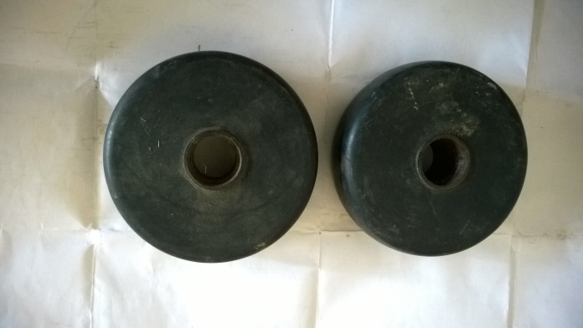

Exhaust tube, new, manufactured 100 €
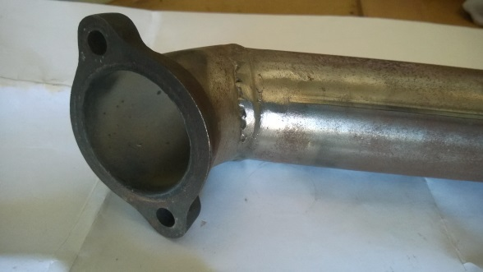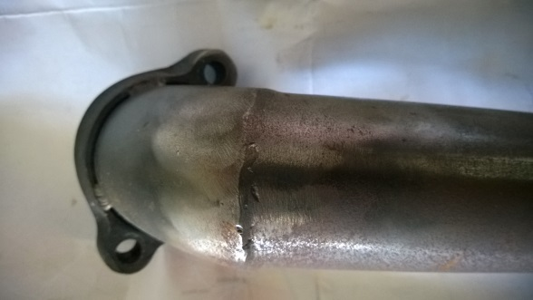

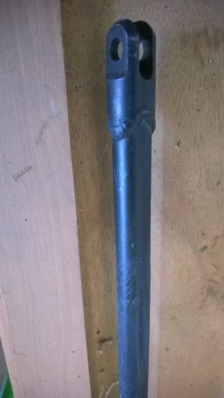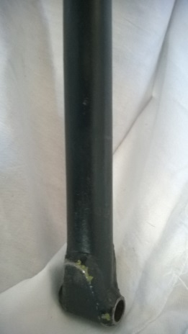
Tornapuntas, small tube for leg, original, good condition 100 €
_____________________________________________________________________________
RADIO MICROAIR VHF all hardware included and intercom (2 or 4 positions) 500 €
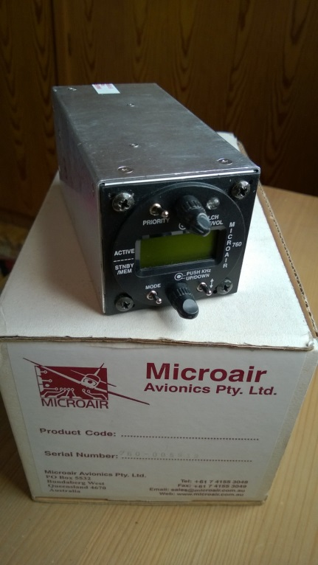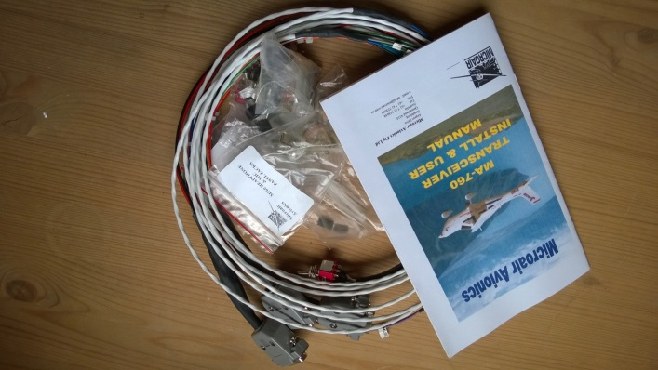

PRESSURE GAGE DOBLE, OIL AND FUEL 300 €
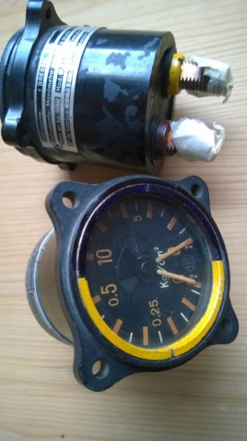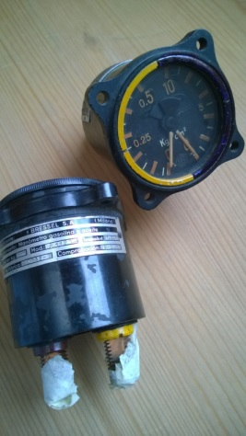

OIL TEMPERATURE GAUGE 250 €
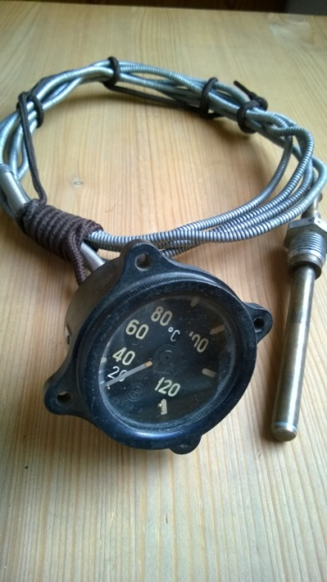

SENNHEISER HEAD SET AND BOOM, AN CONECTOR, NEW 300 €
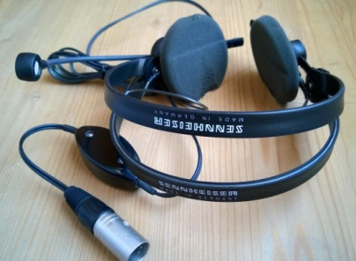

SEATBELTS AND HARNESS, OLD FASHION, AGE OF North American T-6 200 €/each
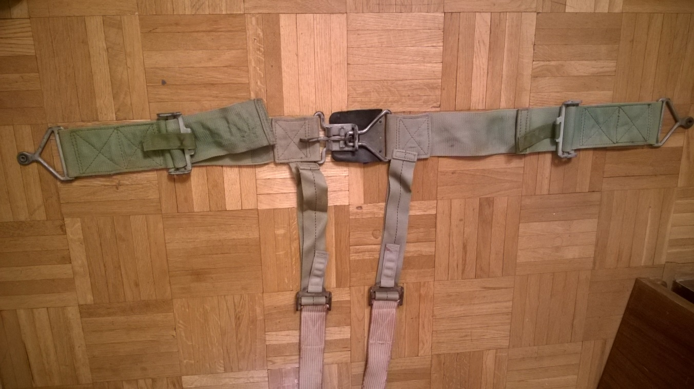
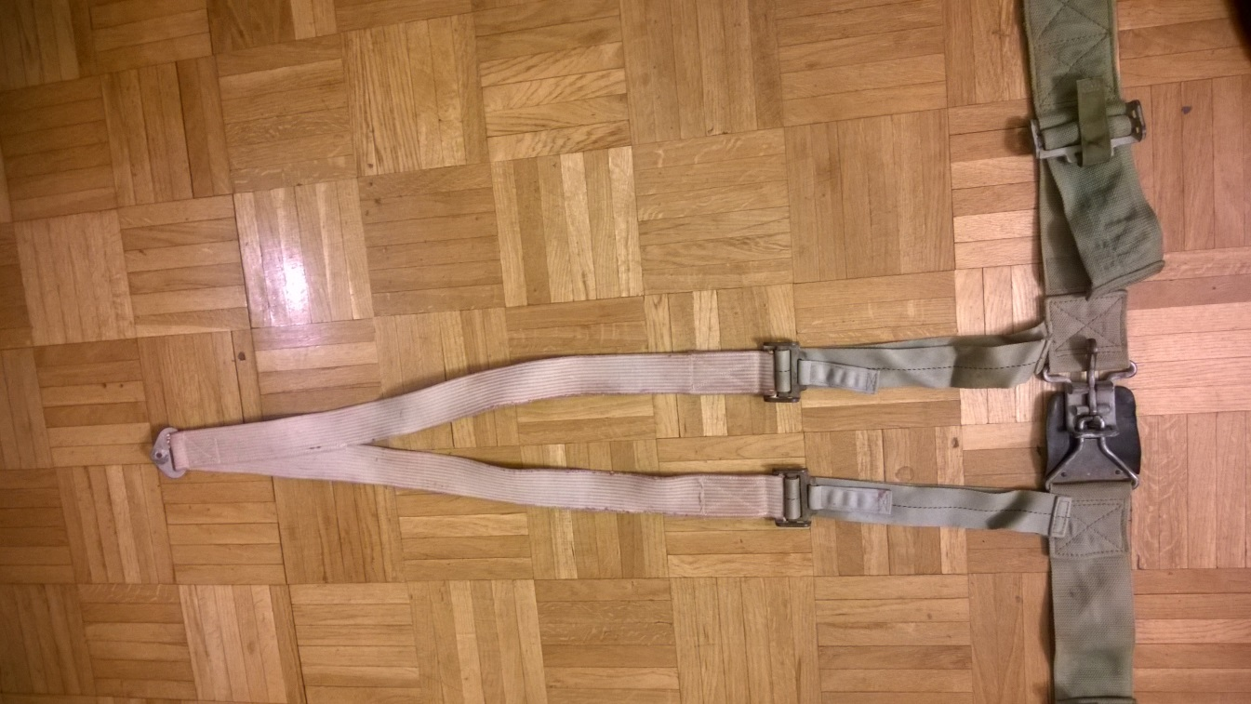

SEATBELTS, OLD FASHION, AGE OF North American T-6 100 €/each
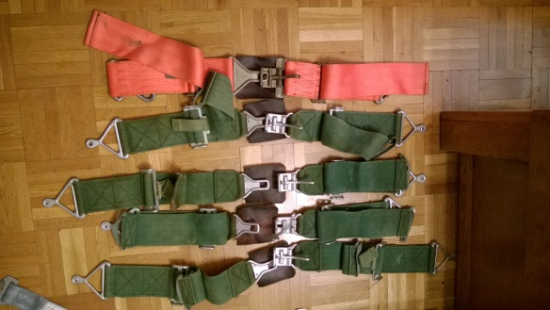

SEATBELTS AND HARNESS, OLD FASHION 150 €/each
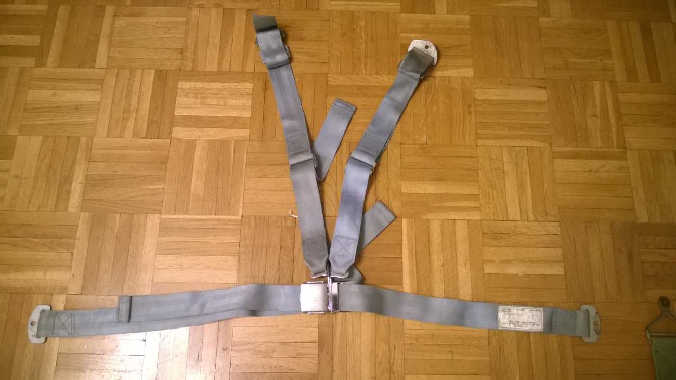

NEW SEATBELTS AND HARNESS, AUTOFLUG 250 €/each
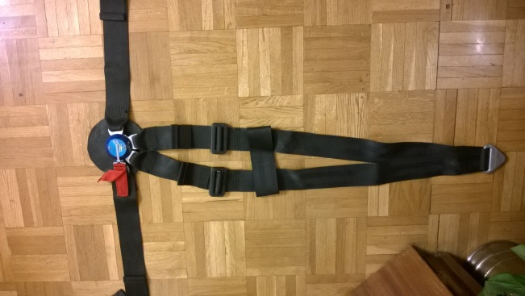

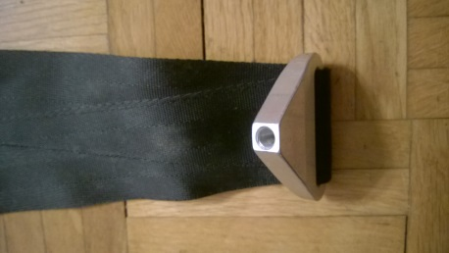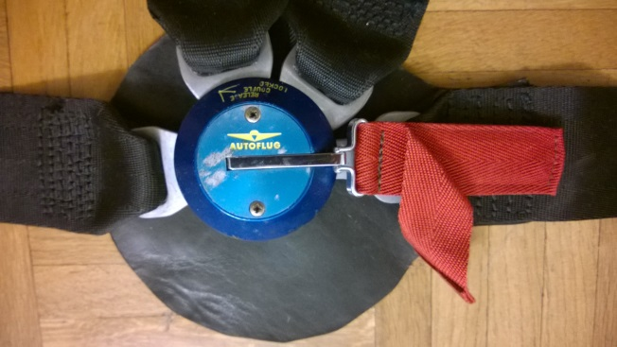

F-86 SABRE OXIGEN MASCK 80 €/each
