2016 West Coast Bucker Fly-in
Information Sheet
Where is the fly-in? The fly-in will be at Classics Hangars (305 Kenney Street, El Cajon CA 92020) located at Gillespie Field in the eastern suburbs of San Diego. This hangar complex includes those owned by the Hickman’s and is the home base for no less than 12 buckers. We were able to get all the visiting Buckers in hangars in 2015 and have outdoor parking for many aircraft between the two hangar rows. Most of the hangars at Classics are equipped with bathrooms, so there will be no shortage of facilities. In fact, some of the hangars are more like living rooms than aircraft storage buildings so plan on being comfortable. PLEASE Send e-mail to the following address if you are planning to attend. We are trying to get a head count: SDBuckerflight@yahoo.com. If you can’t e-mail please call me at 619-977-5931.
See the diagram below for the location on the field and high level orientation to Gillespie field:
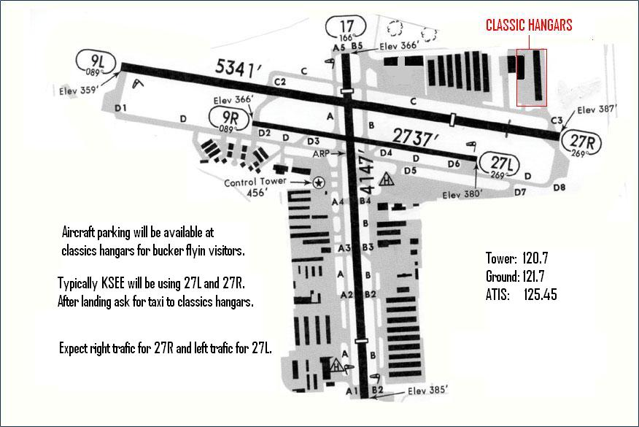
Events
Continuing in the fine tradition of the Santa Paula fly-in, we want to provide a relaxed and social event for Bucker enthusiasts from all over the world. Hence, we plan on offering dinner on Thursday, Friday and Saturday evening at Classics Hangars as well as snacks and beverages throughout the day on all four days.

On Thursday we will have Pulled Pork Sandwiches in the Hickman’s Hangar.
On Friday we will have a catered Mexican dinner in the Hickman’s Hangar:
On Saturday we will have Tri-tip barbecue again in the Hickman’s Hangar.
Cost : We will be asking each participants to pay $35 if they plan to attend one Dinner and $70 if plan to attend two or three. This cost includes the traditional tee shirt.
The 2012 and 2013 event was great hit with everyone who came and we look forward to see more folks in 2014.
Fly outs:
On Friday (as weather allows) we planning a flying tour down San Diego bay. We will fly over La Jolla, around the end of Point Loma and then down San Diego Bay. This will take the group directly past the Bay Bridge and Carrier berthing at North Island as well as provide a spectacular view of the city and the pacific ocean. This was a big hit is 2012 and 2013 - we plan to repeat it. We had a special treat in 2012 as the USS Makin Island (LHD-8: helicopter carrier) was coming up the channel as we flew over. This ship had been overseas for 8 months. See the bucker site for pictures of this flight.

On Saturday we are planning a fly out to Hemet for lunch at the café there or possibly another flight up the coast – depending on what the group prefers.

Where to Stay:
The two hotels closest to the fly-in site are listed here. Both are less than a mile from Classics Hangars. Both are relatively cheap and close. I won’t disparage their accommodations but they are not what you would call high end hotels. If you want to go more upscale or near the coast, etc., there are hotels of every description in San Diego. All of the major chains (Marriot, Hilton etc) are represented and they are all very nice. If you want a unique experience, try the Hotel Del Coronado (about a 30 min drive from the fly-in): http://hoteldel.com/. Also shown below is the Carlton Oaks Golf Course Hotels which is also fairly close to the airport.
Best Western Santee Lodge
10726 Woodside Avenue, Santee, CA 92071-3143
(619) 449-2626 ‎
Rodeway Inn Santee
10135 Mission Gorge Rd, Santee, CA 92071-3813
(619) 258-2020
Carlton Oaks Country Club Hotel
9200 Inwood Drive Santee, CA 92071
Call 619-448-4242
http://www.carltonoaksgolf.com/

Things to do outside the fly-in:
San Diego offers a great deal to do for the visitor and this list in not intended to be comprehensive in anyway. This is intended more to provide some high lights. We are hoping that folks will come to the fly-in early or stay after, bring their families and enjoy San Diego.
Beaches: As native of San Diego, I think that the two best beaches in the area are at La Jolla Shores and Coronado. Both are about a 25 to 30 min drive from the fly in location. Here are links to more information on the beaches:
La Jolla: http://www.sandiego.org/what-to-do/beaches/la-jolla.aspx
Coronado: http://www.sandiego.org/what-to-do/beaches/coronado.aspx

The Zoo: The San Diego Zoo is one of the world’s best Zoos and definitely worth the time. My wife and I go every two months or so just for the walk. Be sure to wear your walking shoes because the Zoo is large and covers a series of canyons and is best viewed on foot. There are bus tours for those who don’t want to walk. You could easily spend an entire day at the zoo. One hint is if you have more than 3 folks buy an annual pass for two you will get free passes for two more, free ride on the overhead tram to the back side of the zoo and discounts on the bus. You will also get free access to the safari park in the north end of San Diego County. http://www.sandiegozoo.org/

USS Midway Museum and San Diego Aerospace Museum: For those of you who cannot get enough airplanes, the Midway and SD Aerospace Museum are right up your alley. The USS Midway (CVA-41) is docked right in downtown San Diego and is about a 20 min drive from Gillespie field. Beyond touring the ship, there are about 25 aircraft on board covering the time period from WWII to today. Part of the tour takes you through the Jr Officer berthing compartments where you can see how John Hickman lived during his days on the Midway’s sister ship. This has been a hit with those that visited every year, certainly worth the trip: http://www.midway.org/
The San Diego Aerospace Museum is located in Balboa Park near downtown San Diego and is about a 20 min drive from Gillespie field. The collection covers the dawn of flight to the present day, including space travel. They have an especially interesting WWI collection and a Japanese Zero fighter.
There is an annex to the San Diego Aerospace Museum located at Gillespie Field immediately adjacent to the fly-in site at Classics Hangars. This facility is their storage site and they have nice collection of “unrestored” aircraft including several USN jet types and even a MIG21. It will be open on the Friday of our fly-in: http://www.sandiegoairandspace.org/

Shopping: Like any large U.S. city, San Diego has many shopping malls that offer the standard stuff you could find almost anywhere. While you’re here if you want something like that, any one of the locals can point you to the closest one to our site. However, if you want a pleasant shopping stroll in a post card setting, I recommend that you visit La Jolla. It is right on the coast and about a 25 to 30 min drive from the fly-in location: http://www.lajollabythesea.com/

Balboa Park: Balboa Park is a complex of museums and park land that was built in 1915 for the Panama Exposition and serves as the “central park” of San Diego. It is right next door to the Zoo and contains the Aerospace museum. It also includes San Diego’s Old Globe Theater. Certainly worth an afternoon: http://www.balboapark.org/

If you have any questions please let me know at: sdbuckerflight@yahoo.com

Chris Overson

